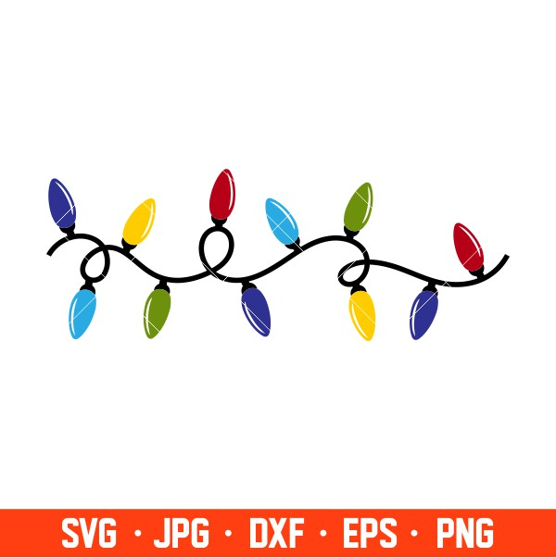
Christmas Crunch

50 Bird Flurry

December 9th

9:00 Registration
$30 Adults $15 Juniors

Lynden Shotgun Club 8823 Weidkamp Rd. Lynden WA
Lunch available after the shoot

